How to do software datalog for DI with PecStar
Software datalog driver
Driver Type: Device driver of saving realtime data as data record
Polling Mode: Parallel
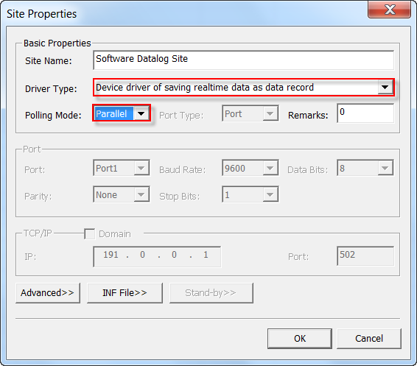
Device Properties:
Device Type: DatalogDevice
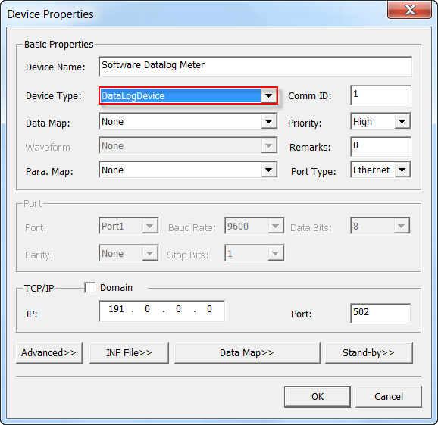
If a device does not support on-board datalog for DI parameters, we can do software datalog in PecStar using a special driver called DrvFormula.
DrvFormula is a driver to perform complex calculations. The user can add a virtual site using this driver and a virtual device named FormulaMeter which does not need additional device license.
Functions:
- Read analog parameters(AI/AO) and digital status(DI/DO) values from other devices or the virtual device
- Perform calculations with the formula
- Display DI/DO status with 0 or 1: 0-Close, 1-Open
- Support display real-time communication status
Site Properties
Driver Type: Mathematical Computation Driver
Polling Mode: Parallel
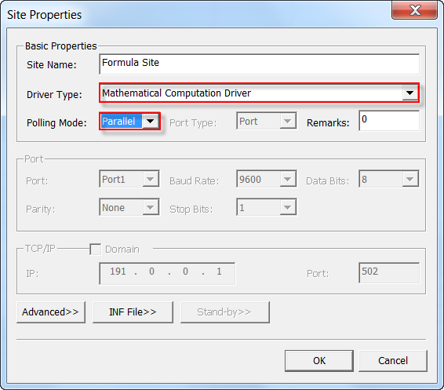
Device Properties
Device Type: FormulaMeter
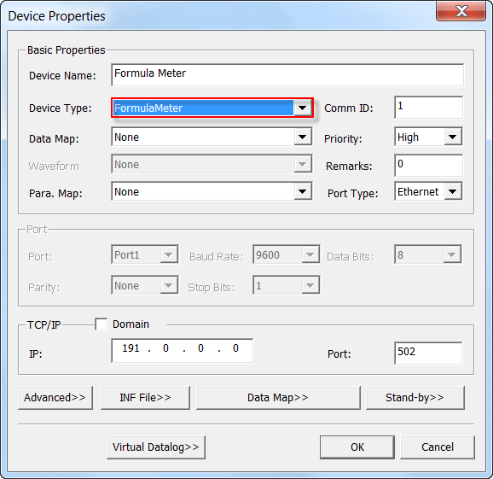
The INF File is consist of Constant field, Data Source field, and Datalog field.
- Constant Configuration
[Constant]
Num=n
V0=3.14
V1=100
….
Vn=-3.1415
[MeasSource]
Num=n
M0=ParaHandle, DataType, MeasId //ParaHandle: Reserved, DataType: Reserved
M1=ParaHandle, DataType, MeasId //MeasId: ID of analog parameters
…
Mn=ParaHandle, DataType, MeasId
[StatusSource]
Num=n
S0=ParaHandle, DataType, StatusID //ParaHandle: Reserved, DataType: Reserved
S1=ParaHandle, DataType, StatusID //StatusID: ID of status parameters
…
Sn=ParaHandle, DataType, StatusID
ParaHandle set to 0. DataType set to 0.
n must start from 0.
Each analog parameters is mapped to a digital parameter. When the AI value is NA, the DI equals to 0, when the AI value is not NA, the DI equals to 1.
Analog Code | M0 | M1 | M2 | Mn-1
Digital Source Code | 10000 | 10001 | 10002 | 10000+n-1
Formula Configuration
[MathOperation]
Num=n //number of formulas
A0= M1-M7*M3+V1*Sqr(M3) //operator: Mn(data source), Vn(Constant), (), does not support number
A1= M5/M0+Sin(Abs(M6))
A2= M1*M4PowerV0
[LogicOperation]
Num=n //number of formulas
D0= !S1^S4|(S4&S2) //operator: Sn(data source), (), does not support number
D1= S0^(S1^S3)&S4
D0= !S1^S4|(S4&S2)
D1= S0^(S1^S3)&S4
The user must add data points in PecConfig and the data point code must the same as the formula code. Analog and digital data points code both start from 0.
Measure ID is automatically assigned by PecConfig
M0=0,0,10
Means M0 is the data point whose ID=10.
The data source for the virtual
A0= M1-M7*M3+V1*Sqr(M3)
Each formula supports a maximum of 128 elements, the elements include operands and operators. The operand can be a formula already defined. If the operands exceed 128 elements, please use two formulas.
Support a maximum of 512 analog data points, 512 digital data points, 512 arithmetic formulas, and 512 logic formulas. If exceed the limits, please use two devices.
Unary operator
Binary operator
Priority
The priority of unary operator is higher than binary operator, recommend use ()
Numeric Formula
Operand | Function | Priority | Description
Binary | + | 2
Single | - | 2
 | * | 1
 | / | 1
 | Sqrt
 | Sqr
 | Power
 | Abs
 | Sin
 | Cos
 | > | 3
 | < | 3
 | >= | 3
 | <= | 3
 | == | 3
 | & | 2
 | | | 2
 | ! | 1
 | ^ | 2

